**President**

**Donald Trump | VP-Mike Pence**

**US Congress**

**District 25** – **Mike Garcia**

*Includes most of Simi Valley*

**District 26** – **Ronda Kennedy**

*Includes a sliver of Simi Valley*

**CA Senate**

**District 27** – **Houman Salem**

**CA Assembly\***

**District 38**\*

**Lucie LaPointe Volotsky**

**Suzette Martinez Valladares**

The excellent news is one of these two **Republicans** will be going to Sacramento! The RVC knows them and believes both are quality candidates! To help **you** decide, we urge you to jot down 3-5 of your most important VALUES. Visit the candidates’ websites then decide who will best represent your key values. Whether your choice wins or loses, you will be able to judge her performance based on **YOUR** values!

**District 44** – **Denise Pedrow**

*Includes a sliver of Simi Valley*

**Ventura Community College District**

**Brian Gilbert** – A **red, white, and blue** businessman running against an avowed **“social justice”** incumbent.

**Simi Valley Unified School District-C**

**Rocky Rhodes** A business owner who wants to change the education status quo for the better.

**Simi Valley City Council**

**MAYOR** – **Keith Mashburn** (At-large vote for all of Simi)

**DISTRICT 1** – **Elaine Litster** (North Simi Valley)

**DISTRICT 3** – **Dee Dee Cavanaugh** (West Simi Valley)

**Rancho Simi Recreation & Park**

**Vote for these three candidates:**

**Kate O’Brien**

**Elaine L. Freeman**

**Steven W. Reeves**

**Calleguas Municipal Water District**

**Raul Avila, A US Navy veteran & engineer**

**Ballot Measures**

**Yes only on…**

**Prop 20** – Strengthens Penalties for Violent Crimes

**Prop 22** – Protects Rights of Independent Contractors

**VOTE NO on all other measures**

Until government performs better for us and does more with what they already get, we should “hold that line!”

Prop 14 – Worsens the deficit

Prop 15 –Raises Taxes (Split rolls/ hurts Prop 13)

Prop 16 – Creates MORE government quotas

Prop 17 – Allows Felons to Vote

Prop 18 – Lowers the Voting Age

Prop 19 – Tinkers with Prop 13 property assessments

Prop 21 – Worsens the Housing Crisis

Prop 23 – Threatens Dialysis Health Costs/Options

Prop 24 –Invades Our Privacy

Prop 25 – Makes “Zero Bail” permanent

**County-Wide Measure O, VOTE NO**

**V**ote NO – Extends Cannabis cultivation into unincorporated areas. (It is already extended too far!)

**The RVC | Republican Values Center** is dedicated to promoting our Constitutional Republic and the values expressed in our founding documents. A person need not be a registered Republican to enjoy what the RVC has to offer. One only needs to cherish the American values that make this nation the most prosperous and generous country the world has ever known.

Since we opened our doors a year ago, we have learned that many good people do not know we are a Constitutional Republic! (We get our name the same place the Republican Party gets its name, our Constitutional Republic.) In 2021, the RVC will become…

AVC | American Values Central!

**Faith ◊ Family ◊ Freedom**



**47 In-Person Vote Centers**

**Vote in-person** at a vote center between

Sat. October 31st and Tue. November 3rd.

Centers are open Saturday-Monday

Oct 31-Nov 2 | 10 am – 6 pm

**ELECTION DAY: Tue. Nov 3**

**7:00 am – 8:00 pm**

**Reasons To Vote In Person**

* Your ballot is not private when it is mailed. Your name, address, & zip appear on the envelope.
* Many hands will touch your ballot envelope.
* Your signature must be verified before the ballot is separated from the envelope. This adds another layer of processing.
* If the signature verification machine kicks your ballot out, a stranger will review your signature.
* The Elections Division works hard to “get it right”, but they also must hire temporary staff to handle the work.

**Forballot envelope drop-off locations visit…**

[**https://tinyurl.com/yycbje69**](https://tinyurl.com/yycbje69)



**The RVC is not about the party.**

**It is about our Constitutional Republic!**

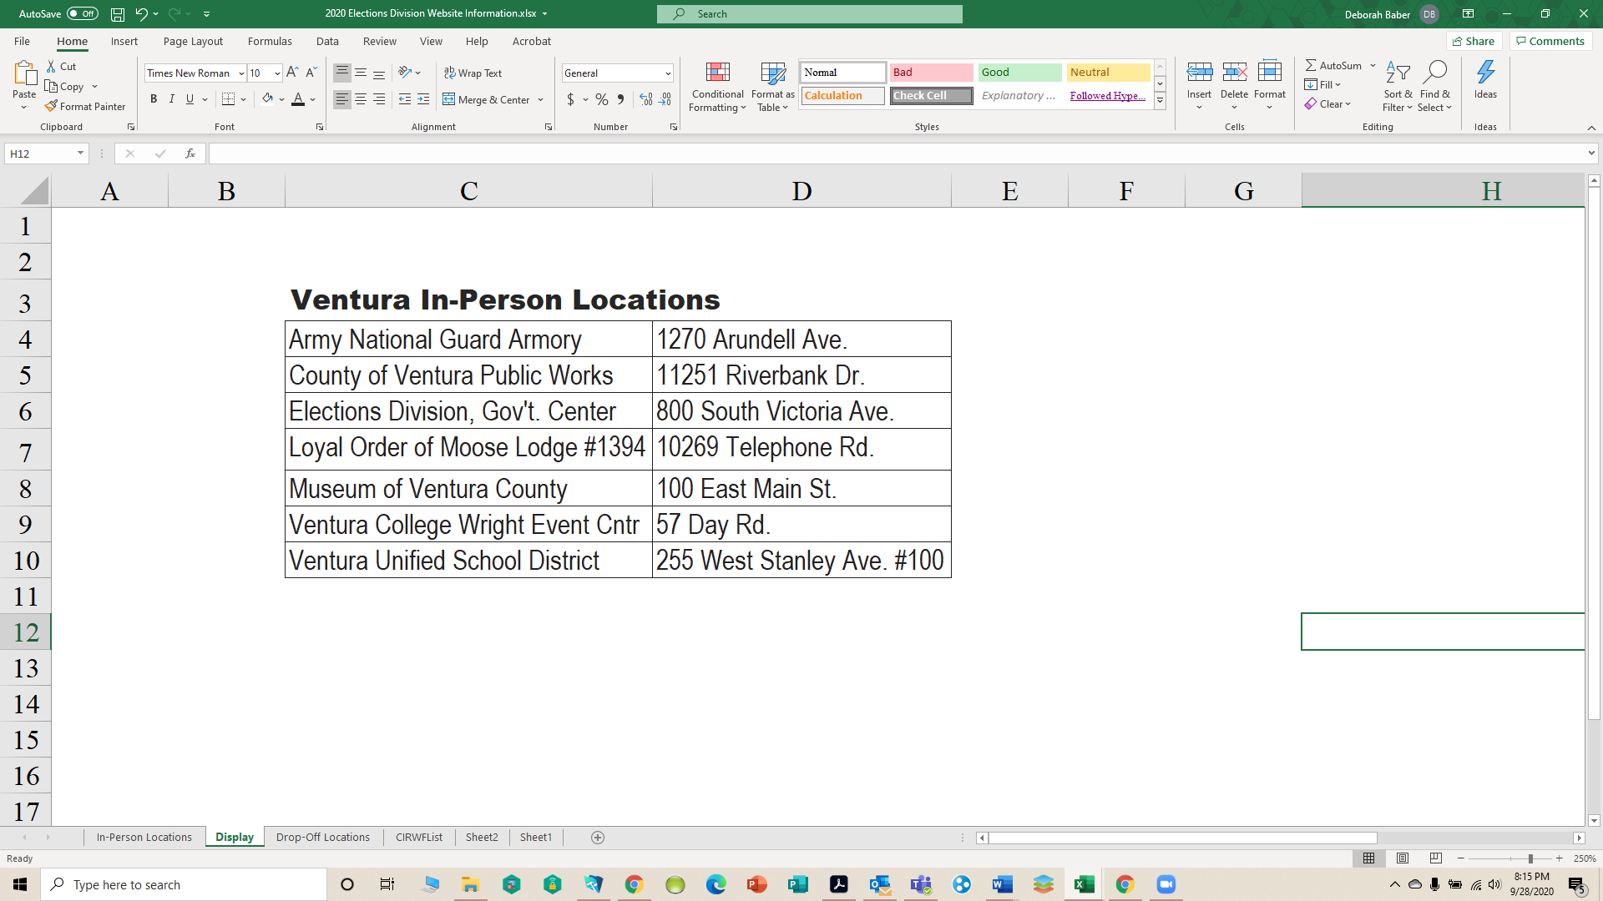

**Our Election Folks are VHP-Very Helpful People!**

**OCT 5:** Ballots will be mailed. The Elections Division suggests you **call if you do not receive your ballot by OCT 15: (805) 654-2664.**

***Every person*** on California’s voter rolls will receive a Vote-By-Mail (VBM) ballot regardless of the person’s last known whereabouts, status, or life span! If your name is on the rolls, ***a ballot Will Be Mailed!*** Lots of challenges!

* The 2020 Election Choice is the most dramatic and profound in our lifetimes. This year American citizens will choose between Democrats’ Socialism versus Republican Donald Trump’s ***America First, MAGA Agenda!***
* **NOT MADE IN THE USA!** Neither the voting equipment nor the company controlling the software are USA-based!
* **Recommendation |Vote-In-Person**
* **Vote in-person** at a vote center between

Sat. October 31st and Tue. November 3rd.

* Ask for an “old-fashioned **PAPER** ballot”.
* **Avoid** using the “electronic pencil”, touch screen, or other electronic machine.
* Take your ballot & envelope with you **ONLY** as a precaution. **Once you vote, DEFACE the ballot & the envelope so it cannot be used.**
* **Track** your ballot delivery to your home.

<https://california.ballottrax.net/voter/>

* If you mail your ballot back OR if you drop it off at a ballot drop-off location or at a vote center, if you have signed up for tracking you can see when your ballot is received.

Voter Guide | Ventura



#WeDoHappy!

***Know BEFORE you Go & Take This with You!***



Ballot Types 148